Complexity Economics: a new paradigm?

Michael Morreau
UiT-The Arctic University of Norway
michael.morreau@uit.no

Some say complexity economics is a new scientific paradigm, in the sense of Kuhn – a revolutionary alternative to earlier economic thought, with its focus on phenomena of equilibrium. I argue that complexity economics can indeed be regarded a scientific paradigm but that it is not revolutionary.

Models, predictions, explanations

Before asking whether complexity economics is a new scientific paradigm I should like to ask, first, whether it is science. Instead it could be, like medicine, or technology, mainly concerned with prediction and control. Then it would be a tool that banks and businesses can use to predict the housing and the stock market, say, rather than a field of scientific enquiry that explains the phenomena it addresses.

According to Kuhn (1977), the distinction between science and technology can be clarified in terms of the different significance they attach to certain theoretical values. These include accuracy, simplicity and the scope of theories.

Accuracy is critical in science, and even small anomalies can require radical theoretical change. In technology, by contrast, a theory that makes calculations simpler can be better than one that is more accurate but also more complicated to work with. Fit to data only needs to be good enough for whatever practical purpose is at hand: for government work, so to speak.

Explanation also carries great weight in science. Newtonian astronomy explains the elliptical orbits of the planets as consequences of gravitational forces; it has a wider scope than Kepler’s laws, which enable us to predict the positions of the planets but do not explain them. One form of scientific progress occurs, then, when a theory explains phenomena that others have merely described, as in this case. In technology on the other hand explanation can be irrelevant to the question of how good a model is. This point is brought home by the example of a perfectly good model in technology that doesn’t explain anything all.

The Air and Space Museum in Washington DC has on display the Apollo Lunar Module LM-2, which was used in ground testing prior to the successful moon landing of the LM-1, in 1969. In fact the two landing craft are qualitatively identical, each a perfect model of the other. Now, the ground tests were done simply in order to predict the behavior of LM-1 under certain conditions. An explanation on the other hand would tell us how the different systems work together and, in the case of failures, which facts about the materials of which it was constructed were responsible. We’d consult blueprints and books on metallurgy for this, though, not the identical model. The building and testing of LM-2 was an effort in technology, not science.

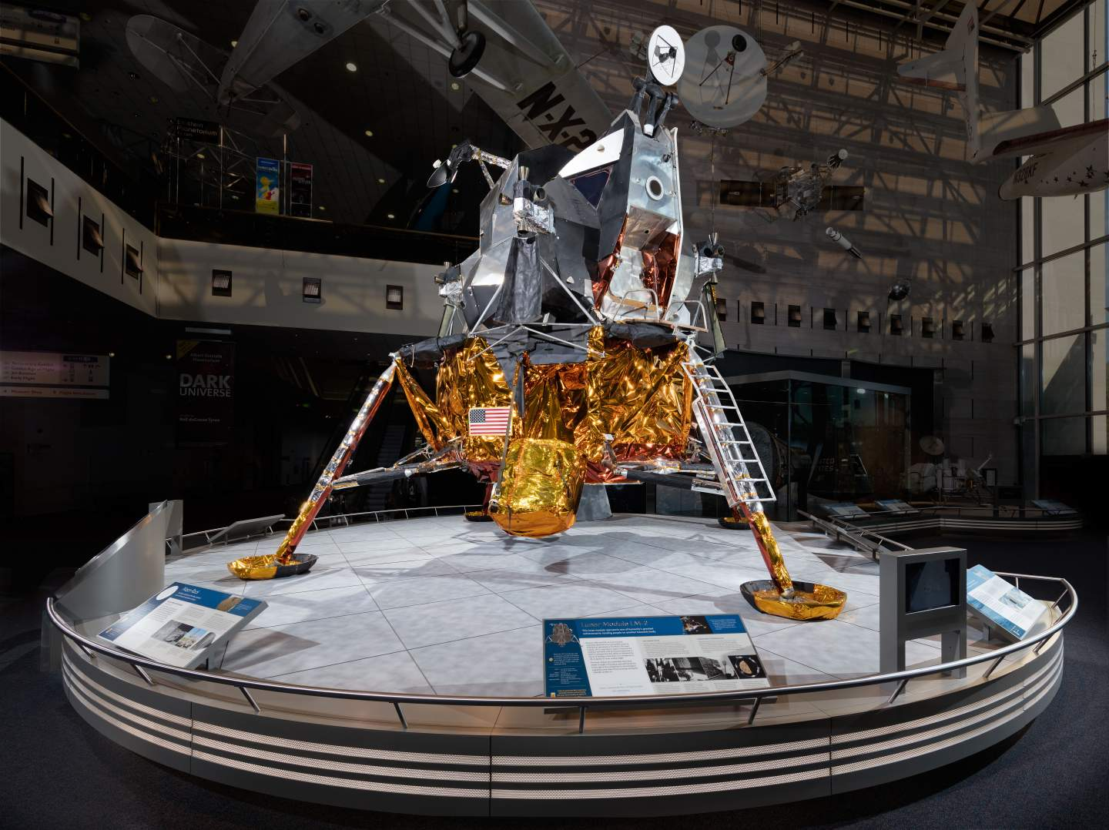

The Lunar Module LM-2 in the Air and Space Museum in Washington DC.

Complexity economics has in common with many scientific fields that modeling is central to it. And so the question of whether complexity economics is science or technology is, in part, the question of whether its models explain the phenomena they address in addition to predicting or reproducing them.

Much philosophy of science has addressed the question what it is for a theory to explain. The received view and starting point for contemporary philosophy of science is the nomological-deductive or “covering law” account, in which to explain a phenomenon is to subsume it under a general regularity or scientific law. The derivation of Kepler’s laws of planetary motion from Newton’s law of gravitation is a canonical example of this. A model though --- whether a physical object like LM-2 or a multi-agent simulation running on a computer -- is not itself a body of laws. Nor is there any obvious ways in which it entails these. The question then is what it is for a model to explain the behavior of its target. It is to this question that I now turn.

I propose that to the extent that models explain, they do so by isolating, from among all the features of their target, some that by themselves sufficient to account for the relevant behavior of the target. For a simplistic example, take a model airplane. Like the real thing it has wings. Unlike the real thing it is made of foam plastic. The model like the real airplane can fly, though, and it points to an explanation of how it is that the latter develops the necessary aerodynamic lift. Take away the wings and the model no longer develops lift. Make it of something else, such as balsa wood, and still does. Having wings is for this reason a part of the indicated explanation of how the real airplane develops lift, while its being made of aluminium is not.

It is helpful here to distinguish Aristotelian from Galilean idealizations in science. This helps us to frame this proposal about explanatory models more precisely, and marks an important difference between complexity and equilibrium economics. Roman Frigg and Stephan Hartmann (2018) explain the distinction as follows:

Aristotelian idealization amounts to “stripping away,” in our imagination, all properties from a concrete object that we believe are not relevant to the problem at hand. This allows us to focus on a limited set of properties in isolation. An example is a classical mechanics model of the planetary system, describing the planets as objects only having shape and mass, disregarding all other properties. […] Galilean idealizations are ones that involve deliberate distortions. Physicists build models consisting of point masses moving on frictionless planes, economists assume that agents are omniscient, biologists study isolated populations, and so on.
The point then is that what enables some models to explain phenomena, or at least point in the direction of explanations, is that they embody Aristotelian idealizations. This idea is not original with me. Many philosophers of science have put forward some version of the idea that whereas Galilean idealizations are there to make theories tractable, Aristotelian idealizations are there to isolate causes and explain.

Let us now ask whether the models of complexity economics merely predict or reproduce phenomena, or whether they can also explain them.

Thomas Schelling’s seminal (1969, 1971) model of segregation is a simple of a multi-agent model. Counters of two kinds are distributed on a board with some empty spaces in between. They stand for people of two different kinds, whether coloured or white, male or female, smoker or nonsmoker or what have you.

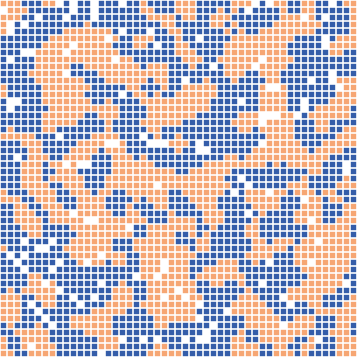

Screenshot from an implementation of Thomas C. Schellings classic analysis of the emergence of segregation in societies. From video posted by to YouTube by Michael Mäs: https://www.youtube.com/watch?v=dnffIS2EJ30.

The counters are assumed to have a certain “level of tolerance” for the proportion of counters of the other kind among their immediate neighbours, and their resulting movements are governed by a simple rule. Provided the proportion of dissimilar neighbours is below tolerance, a counter stays put. If the proportion exceeds tolerance level the counter moves to an unoccupied space.

What emerges is, however well known, still amazing. Even with what in real people must count as a high level of tolerance for diversity, the collection of counters quickly segregates itself into homogeneous clusters. This is taken to explain the segregation that is observed in some real societies that are racially diverse.

But how, you might ask, could it do any such thing? The counters, after all, don’t resemble people very closely at all. Nor do the x’s and o’s written on a page, or the zinc and copper coins that Schelling was experimenting with at first, when he discovered the model.

In fact it is precisely because the agents in the model are in many ways unlike real people that Schelling’s model can hope to explain the behavior of the latter, rather than just reproducing it. Notice that this is an Aristotelian model, in that it does not purport to represent all features of real people. And it is a realistic Aristotelian model, to the extent that it is faithful to those few features that it does represent: people really could be inclined to get up and move somewhere else if more than, say, 30% of their neighbours are of another race.

Contrast the moon landers. LM-2 is much more similar to LM-1 than an x on a page or a zinc penny is similar to a real person. The two landing models are qualitatively identical, as similar as can be. The flipside of this perfect realism, though, is that LM-2 does not explain the behavior of LM-1, no matter how accurate are the predictions that it enables engineers to make. LM-2 is not a realistic Aristotelian idealization --- not because it misrepresents any features but rather because it is not an idealization at all: it represents all features of its target, LM-1, leaving nothing out.

Schelling’s model, on the other hand, can be counted as an explanation. Practically all features of real people that might be thought relevant to segregation behavior --- their incomes and the cost of housing, their preferences for employment and schooling and the physical locations of opportunities for these --- all these have been left out of the model, with the exception of tolerance for diversity among immediate neighbours. Precisely because the agents inside the model and real people do not share all their features, such features as are common to them can be held causally responsible for the similar behavior of both.

This seminal example of multi-agent simulation can in this way be counted as an explanation. And the same can be said of other models in complexity economics, whether of housing or stock markets of what have you. Their Aristotelian idealizations abstract away many features of real people and social institutions. And they do so without introducing Galilean idealizations such as perfectly rational agents, or unlimited knowledge, which would undermine realism.

Is Complexity Economics a Paradigm?

I’ve been asked in this talk to comment on whether complexity economics is a scientific paradigm in the sense of Kuhn. The answer is bound to be unsatisfying because there is no one Kuhnian sense. Not one, not even a few: Margaret Masterman (1970) counts twenty one distinct senses of this central notion in Kuhn’s The Structure of Scientific Revolutions. All we can ask here is whether complexity economics is a paradigm in some Kuhnian sense. That is what I turn to now.

Here is one criterion that Kuhn proposed for distinguishing paradigms in science. A mode of activity should be “sufficiently unprecedented to attract an enduring group of adherents away from competing modes of scientific activity” and “sufficiently open-ended to leave all sorts of problems for the redefined group of practitioners to resolve.” (Kuhn 1962, p. 342) Work in complexity economics surely fills this bill. Following the seminal Santa Fe conference of 1987, where economist Kenneth Arrow and Physicist Philip Anderson and other scientists discussed the possibilities for modeling economies as evolving systems, complexity economics has attracted many prominent researchers and it has taken on many interesting and important problems such as the evolution of markets and the emergence of cooperation and norms in societies.

Work in complexity economics surely also exhibits a characteristic feature that Kuhn associated with enquiry within a scientific paradigm, or what he called “normal” science. This is that models may be adapted to accommodate anomalies rather than discarded as false. An example of this in astronomy is adding epicycles to the orbits of heavenly bodies, to bring predictions into agreement with observations.

For a very simple example, take the tolerance parameter in Schelling’s model. The less tolerance the simulated agents have for dissimilar neighbours, the more extreme is the segregation that emerges in the model. So a sociologist might tune this parameter to bring the segregation produced by the model into agreement with that observed in a real society, and hypothesize that the tuned in tolerance level is responsible for the segregation observed in the real society.

A critic inspired by Karl Popper’s philosophy of science might object that this is unscientific. The Kuhnian will point out in reply that tuning models to fit data is normal practice wherever models are in use, in science as well as in technology. This is of course not to say that there are no limits to how much tuning is desirable in any given case: it’s possible to “overfit” models by treating noise in the data as signal, and the accuracy of predictions suffers as a result. But the problems of overfitting and ways of avoiding this are well known.

Is Complexity Economics a New Paradigm?

Kuhn’s (1962) examples set high expectations for would-be scientific revolutionaries. There is the monumental change from Ptolemaic geocentric astronomy to Copernican heliocentric astronomy. There is the change from Aristotelian teleology to Newtonian dynamics. These transitions are among the greatest human achievements of all time.

But Kuhn sometimes characterized paradigms in terms that make it sound as if paradigm change and scientific revolution might occur regularly, on a more modest scale. Certainly many developments are “sufficiently unprecedented” to attract researchers away from other projects and also “sufficiently open ended” to keep them busy for a while.

Is complexity economics a revolutionary development of the second, more modest sort? I suggest that it is not. Equilibrium economics focuses on static systems, setting aside phenomena that arise in interactions among parts of developing systems. Complexity economics addresses these developing systems, but it need not ignore equilibrium states, or deny that they exist, or insist that what has been said about them in the past must be wrong. Complexity economics can be conceived of as subsuming equilibrium economics as a special case.

By contrast, Newtonian and Aristotelian dynamics disagree not only about which phenomena need explaining, but also about which the basic notions are in terms of which any explanations of them are to be framed. The relationship between complexity and equilibrium economics is perhaps more like that between Newton’s account of the solar system and Kepler’s, where the one doesn’t come in place of the other but rather fills in what it leaves out. Significant progress is made as we pass from the earlier account to the later one but this progress conserves what was there before.

What would it take to conclude that complexity economics is revolutionary, in some sense that Kuhn might have recognized? For instance, a significant reassessment of the relative importance of the theoretical values could make this plausible. The reassessment should be such that what counts as scientific progress beforehand does not do so after the reassessment has taken place, so that scientists talking across the divide between approaches will in some instances not be able to agree about whether progress has occurred.

For an example of this in astronomy, adding “epicycles” is now almost synonymous with adding complexity to a theory in order to fudge accuracy, instead of undertaking a necessary deeper revision. This metaphorical use of “epicycle” comes from our modern understanding that adding circles on circles to Ptolemaic and Copernicus’s models of the solar system did not improve them but if anything made them worse. It did so by covering over their false a priori assumption that the orbits of heavenly bodies must be circles, rather than the ellipses we now know them to be. From the perspective of early astronomers working within these traditions though, firmly attached to this metaphysical assumption, adding epicycles could count as progress.

Perhaps work in complexity economics has brought a reassessment of the importance of accuracy in relation to that of computational simplicity. David Colander (2008) seems to think so:

Say one is trying to understand an interaction between investment and
changes in income. Standard economics would develop a simple analytically-solvable model—for instance, the Samuelson multiplier/accelerator model—that has a set of deterministic solutions, and then use that to study a variety of cases. In the complexity approach, one would try hundreds of variations of non-linear models, many with no deterministic solution, which capture the dynamic interactions and rely on the computer to show which model best fits the data. One would, of course, study the general properties of non-linear models, but whether the models have analytic solutions would not be a relevant choice criterion as it is now; the choice criteria would be "fit with the data." Elegance and analytic solvability of models are de-emphasized. (Colander 2008, p. 6, my emphasis)

I don’t know whether there are examples of theoretical changes that are taken to be progress in equilibrium economics but which from the perspective of complexity economics are regressive. If there are some then these could be a reason to count a shift from equilibrium to complexity economics as a revolution, in a Kuhnian sense.

I don’t believe though that Kuhn himself would have counted complexity economics as a revolutionary development. In later years he came to compare revolutionary change in science to speciation. He argued that it requires inability to communicate across the divide between different groups of practitioners, just as speciation requires genetic isolation:

The biological parallel to revolutionary change is not mutation, as I thought for many years, but speciation. […] I am increasingly persuaded that the limited range of possible partners for fruitful intercourse is the essential precondition for what is known as progress in both biological development and the development of knowledge. (Kuhn 2000, p. 99)

Now, I don’t see how communications with equilibrium economists could somehow stymie progress in complexity economics. Especially in light of Arrow’s role in convening the Santa Fe conference that started it all, it seems more likely to me that complexity economics will continue to benefit from the back and forth.

Bibliography

Colander, David, 2008. “Complexity and the History of Economic Thought.” Middlebury College Economics Discussion Paper No. 08-04. Department of Economics, Middlebury College, Vermont.

Frigg, Roman and Hartmann, Stephan, 2018. “Models in Science,” The Stanford Encyclopedia of Philosophy (Summer 2018 Edition), Edward N. Zalta (ed.), forthcoming URL = <https://plato.stanford.edu/archives/sum2018/entries/models-science/>.

Kuhn, Thomas, 1962, The Structure of Scientific Revolutions, Chicago: University of Chicago Press.
Kuhn, Thomas, 1977. “Objectivity, Value Judgment, and Theory Choice,” in The Essential Tension, Chicago: University of Chicago Press: 320–39.
Kuhn, Thomas, 2000, The Road Since Structure, J. Conant and J. Haugeland (eds.), Chicago: University of Chicago.

Masterman, Margaret, 1970. “The Nature of a Paradigm,” in I. Lakatos and A. Musgrave (Eds.), Criticism and the Growth of Knowledge, London: Cambridge University Press: 59-89.

Schelling, Thomas C., 1971. “Dynamic Models of Segregation,” J. Math. Socio. 1: 143-186.

Schelling, Thomas C., 2006. “Some Fun, Thirty-Five Years Ago,” in: Leigh Tesfatsion & Kenneth L. Judd (ed.), Handbook of Computational Economics, edition 1, volume 2, chapter 37: 1639-1644 Elsevier.

Schelling (2006) nicely relates the story of his discovery, starting with some experimentation with pen and paper on an airplane trip and continuing later at home with his son’s coin collection.

